**IAM Tasks:**

1. **Create one IAM user and assign ec2, s3 full access role:**

* **Review Page:**

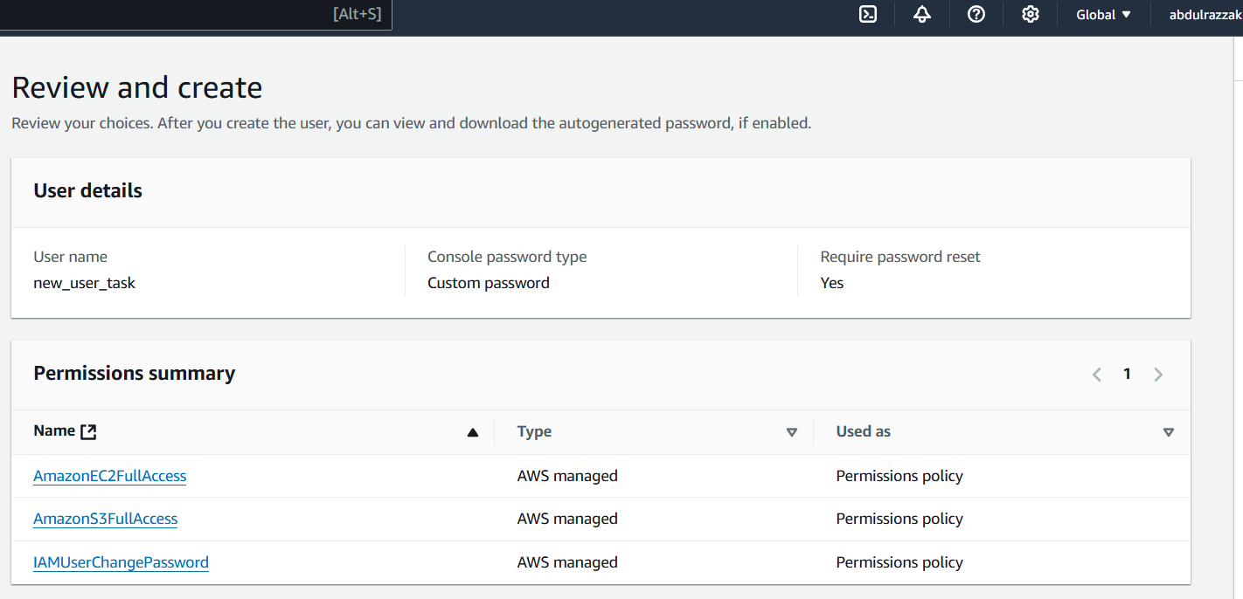

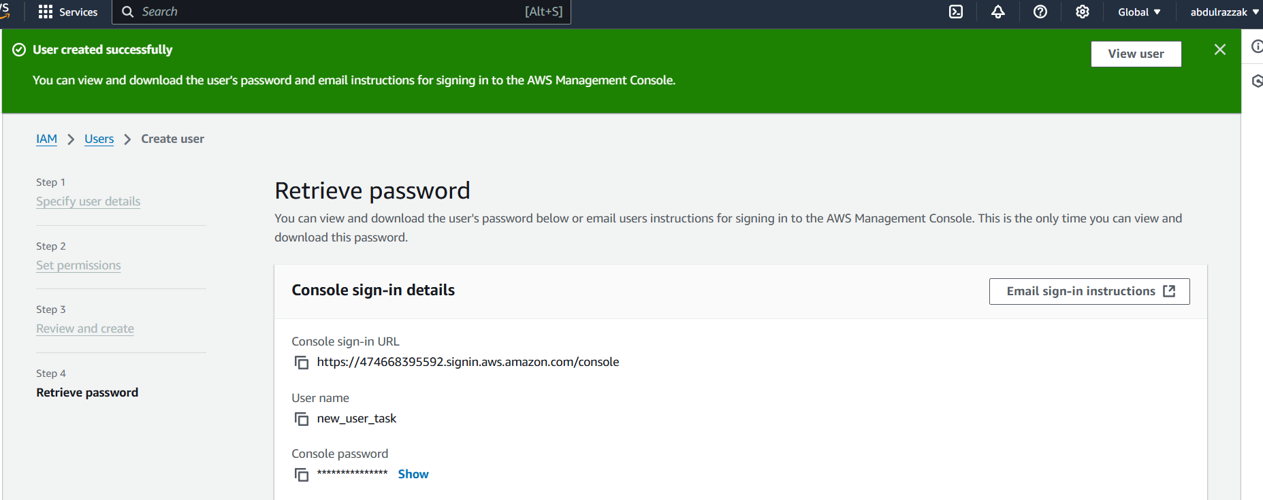

**User successfully created:**

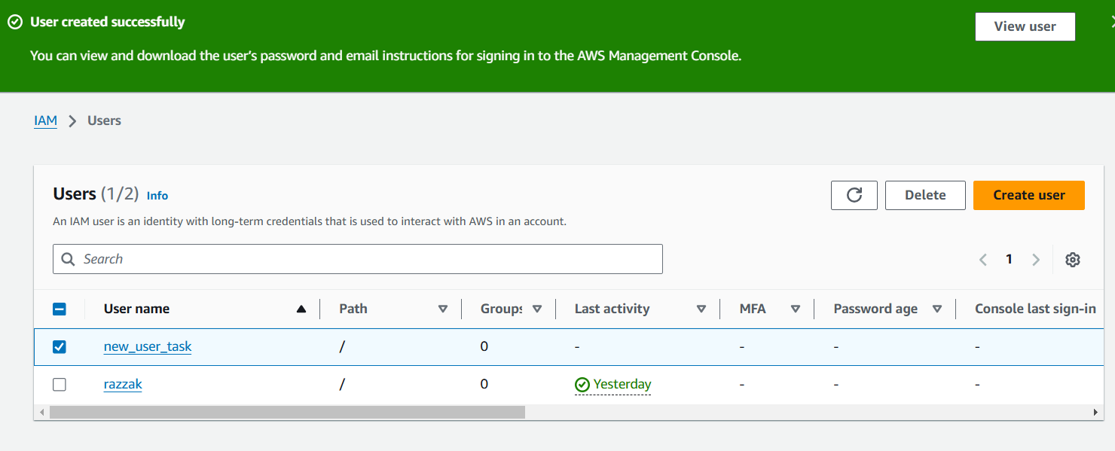

**Signed in as new user:**

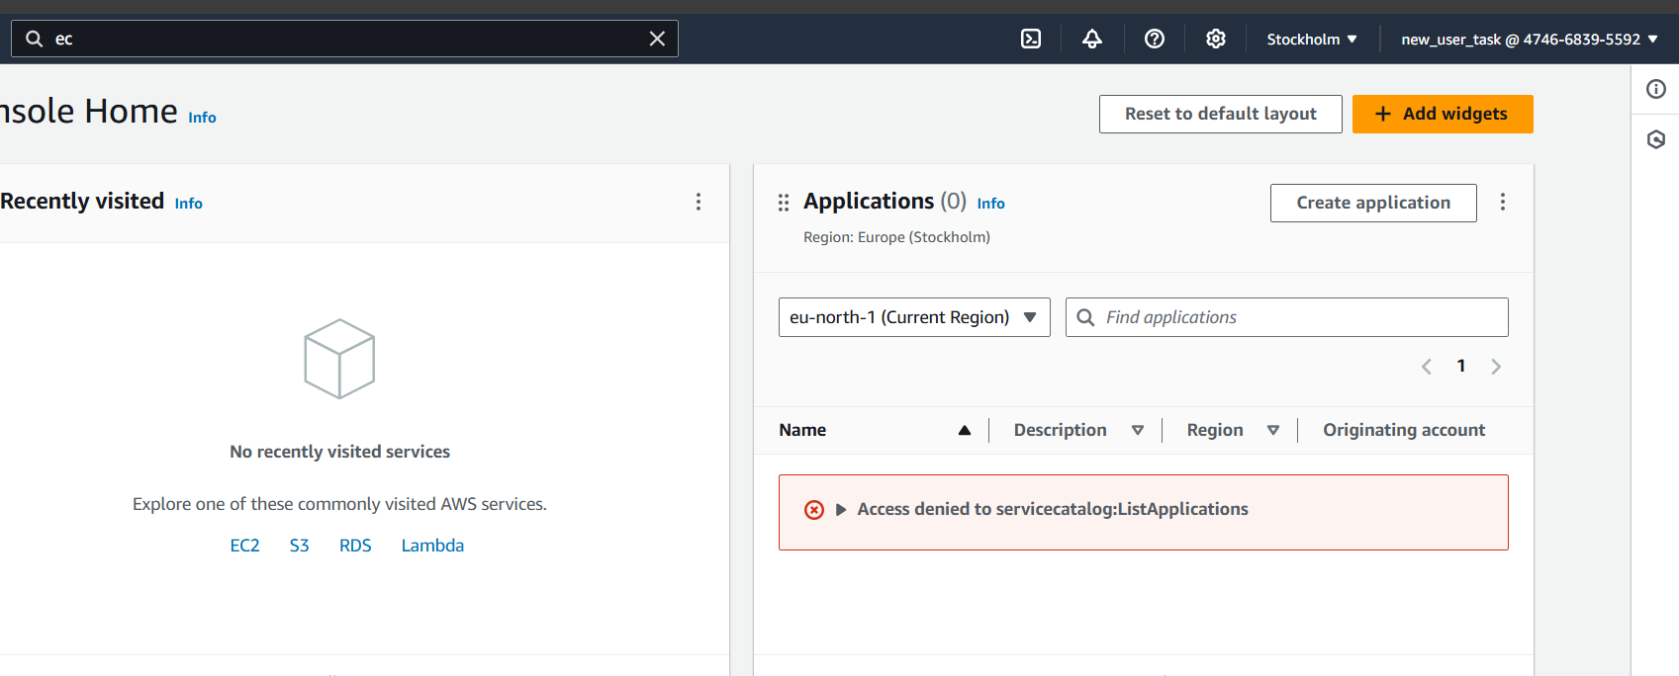

**Ec2 dashboard:**

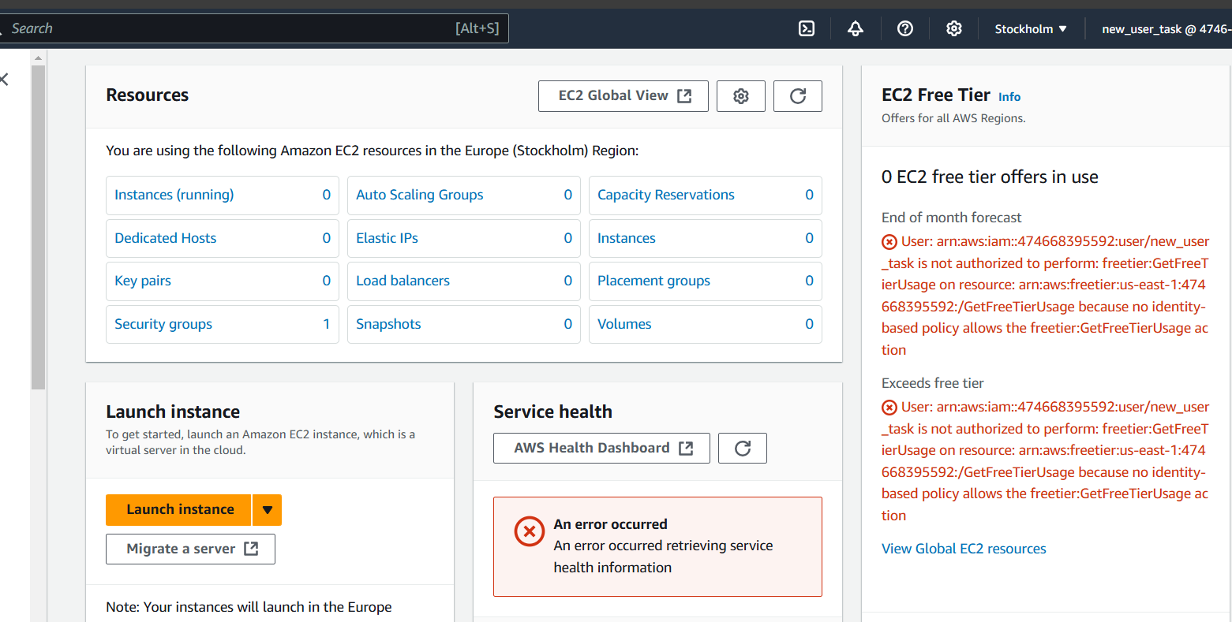

**S3 Bucket dashboard:**

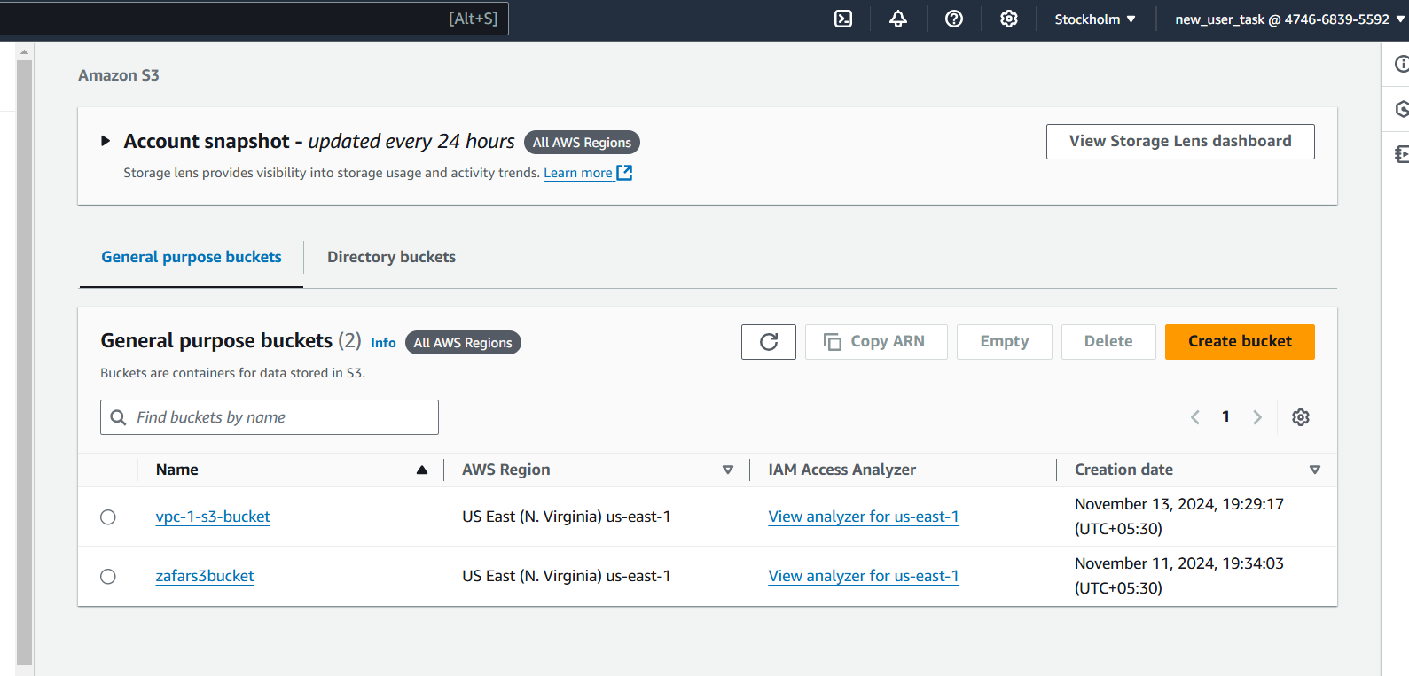

**2)Create one Group in IAM and Assign Read access for ec2:**

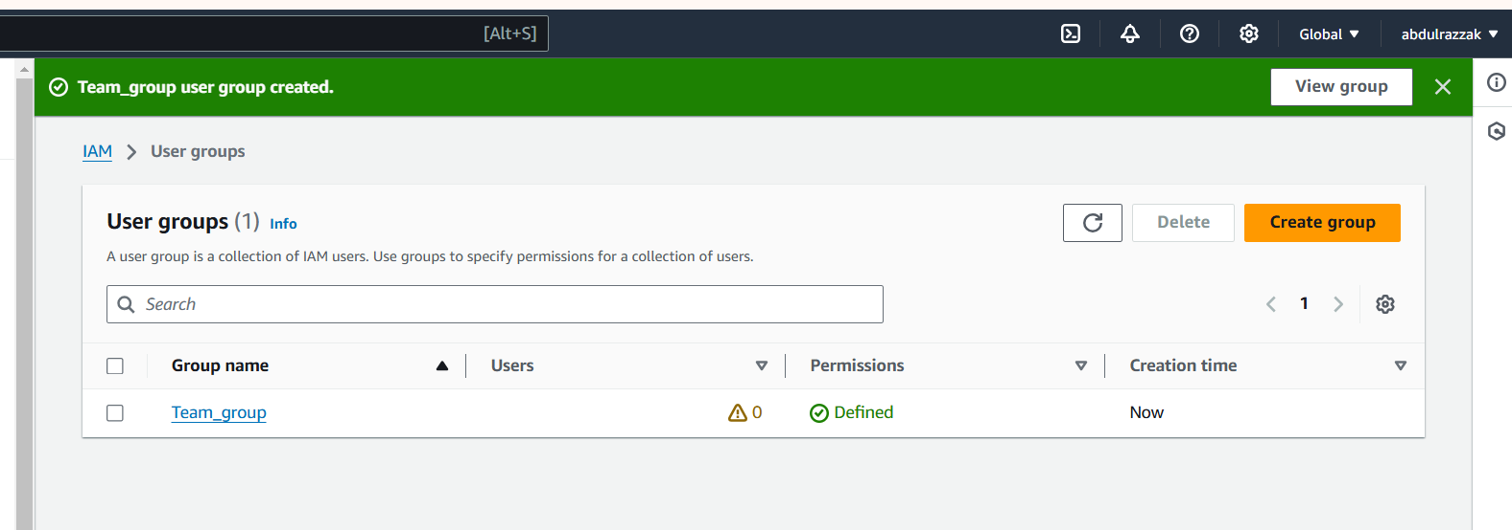

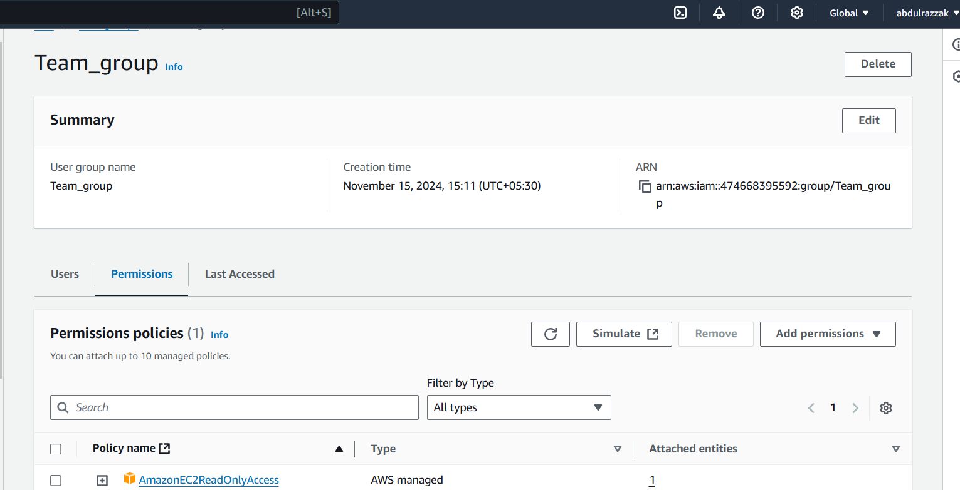

**3)Create a new user with name Devops and add to the group created in task2.**

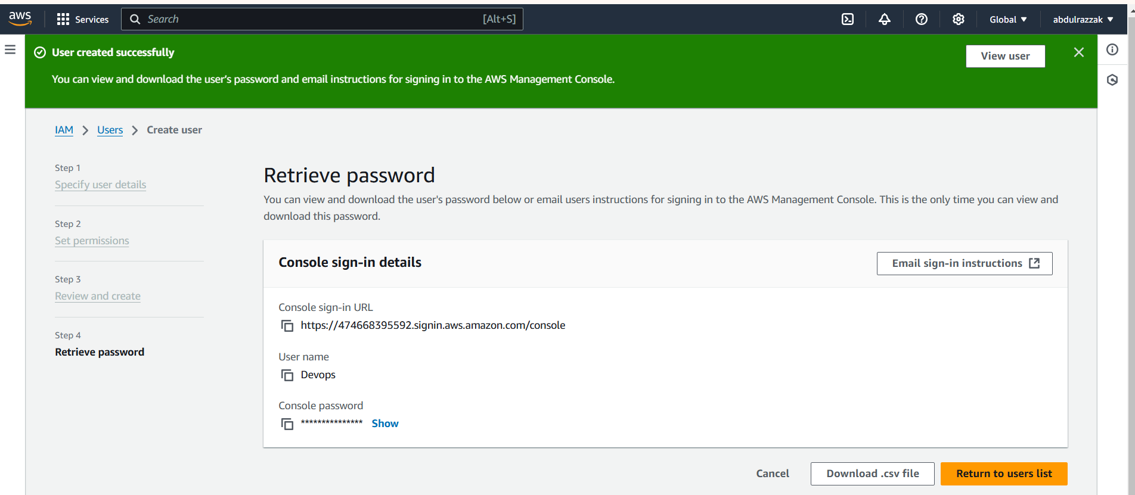

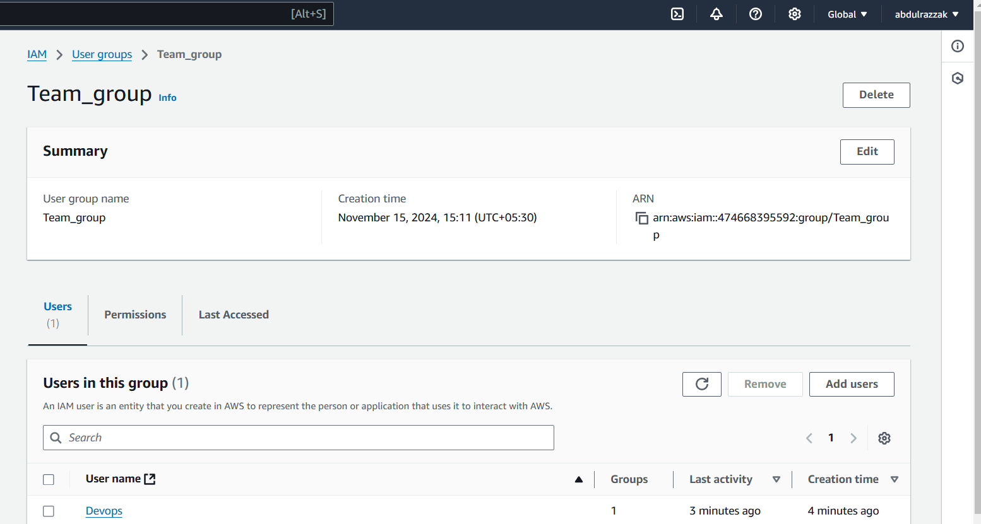

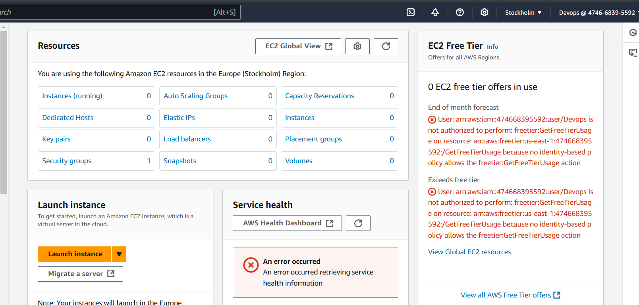

**4) Write a bash script to create a IAM user with VPC full access.**

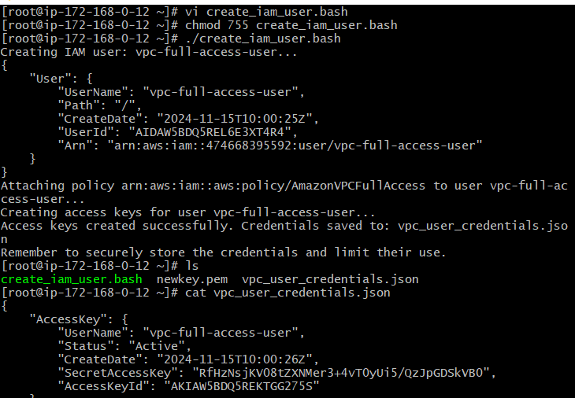

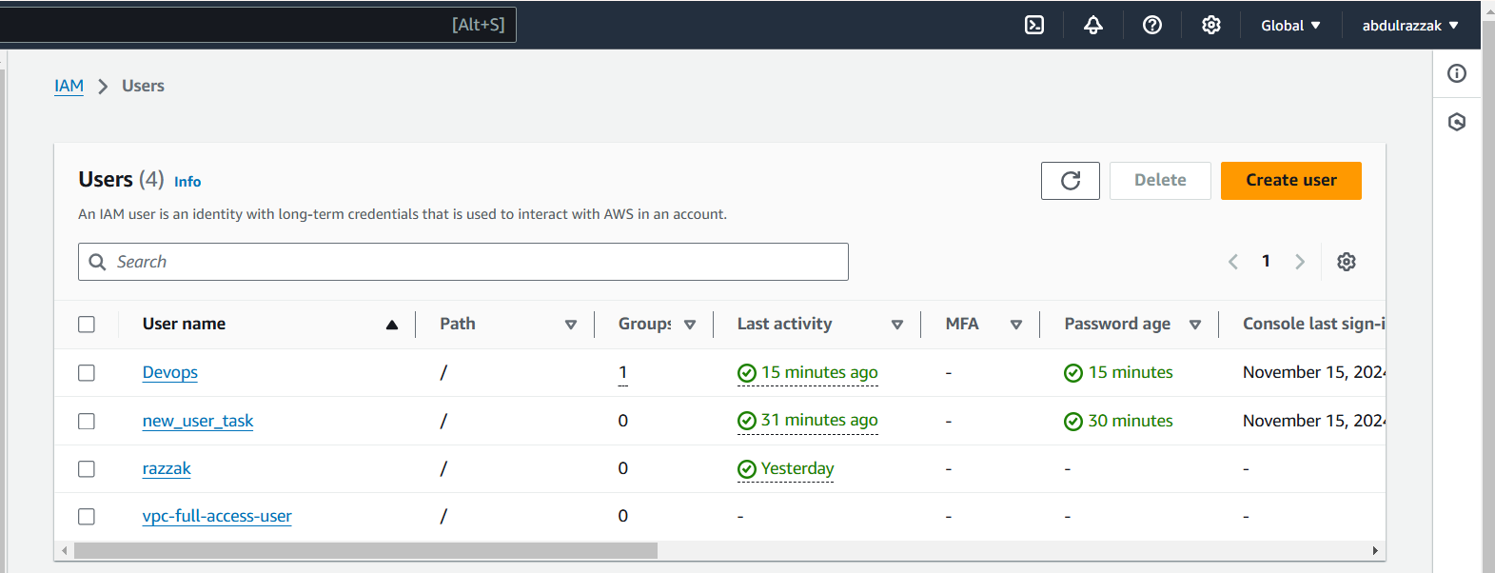

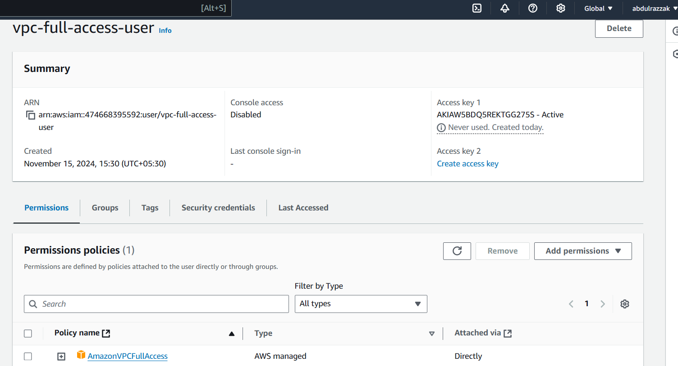

**5) Create a IAM policy to access ec2 for a specific user in specific regions only.**

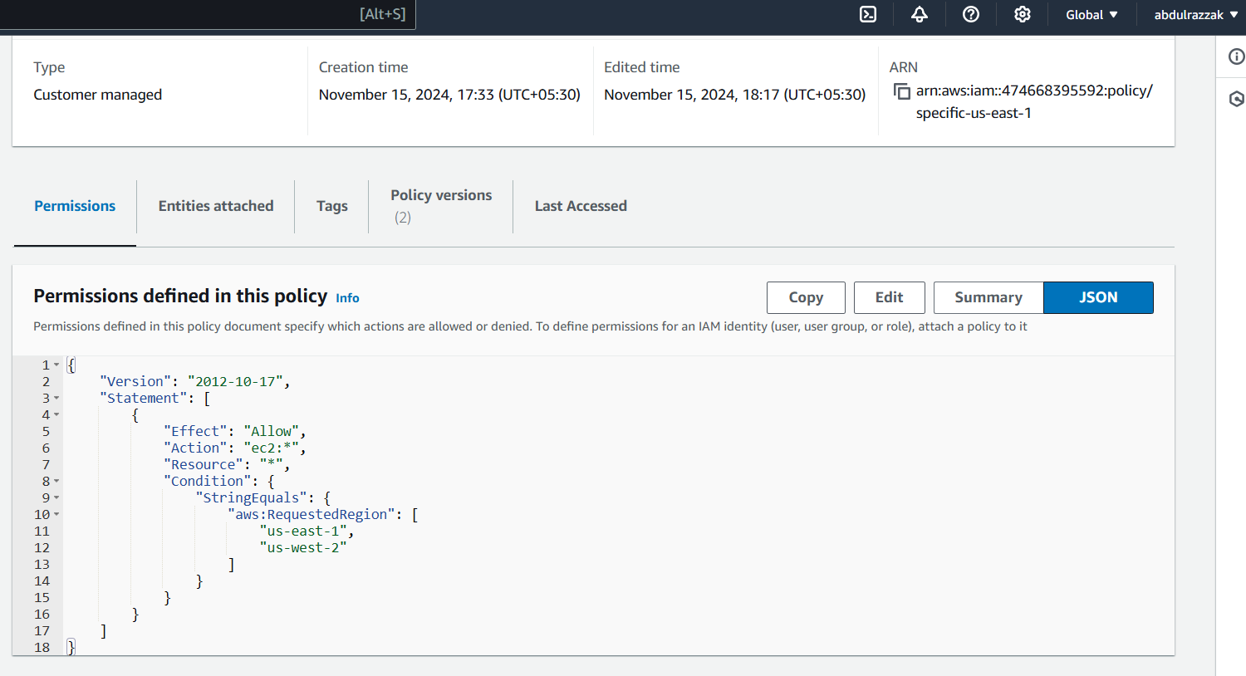

**Attaching policy to the user:**

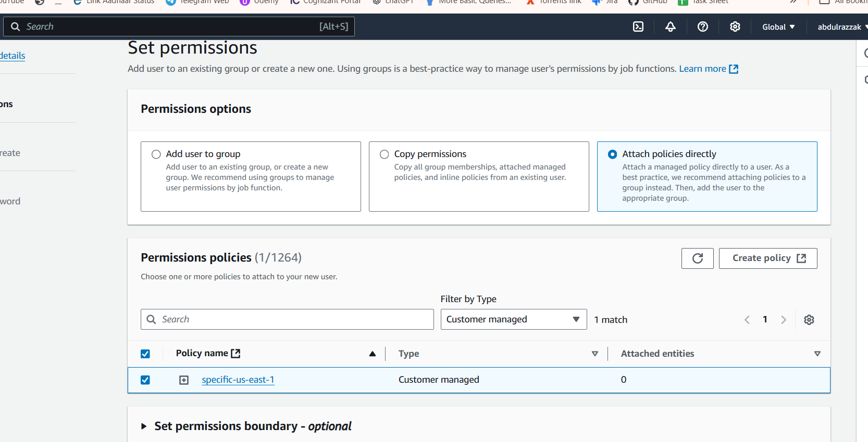

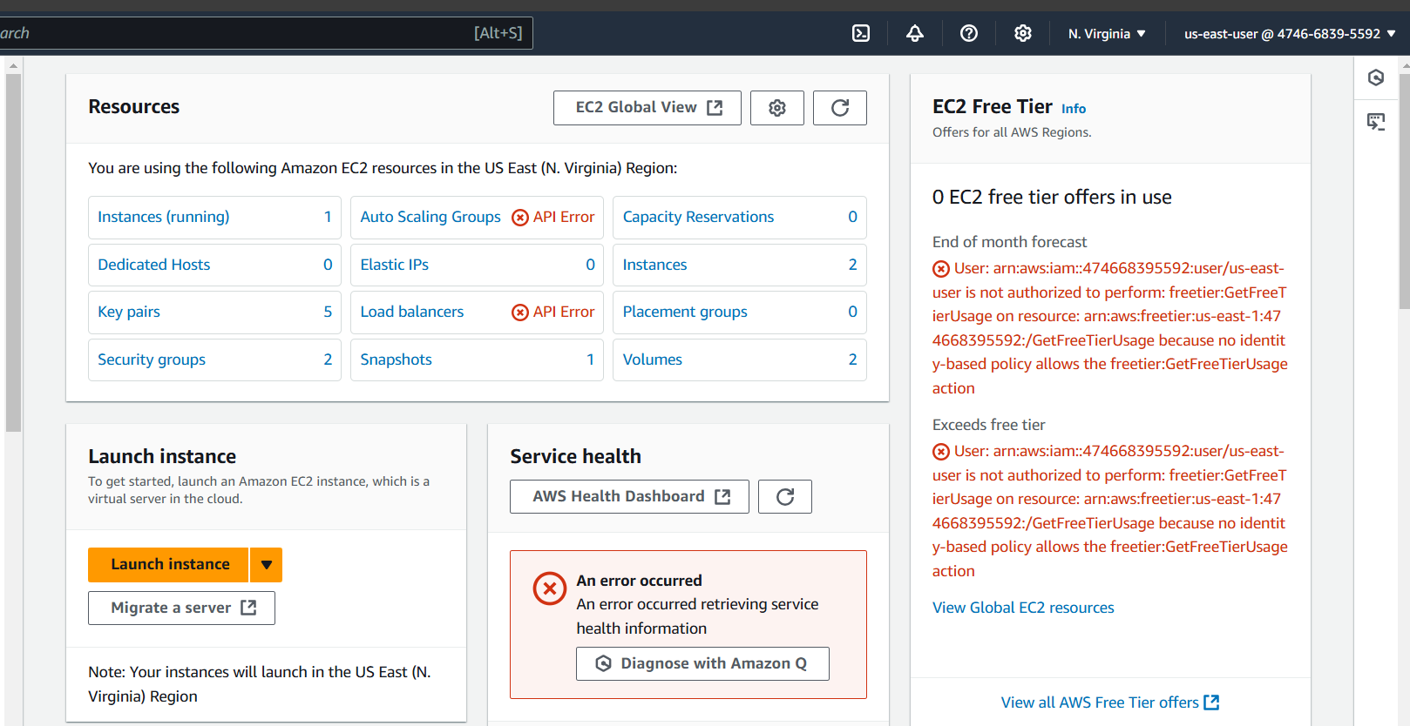

**Tried changing the region to ohio: Not authorized.**

